**Customer Churn Analysis Report**

🔹 **Introduction**

-----------------------

Customer churn refers to the percentage of customers who stop using a company’s services over a given period. Understanding why customers leave is important for improving retention strategies.

In this report, we analyze customer churn data using visualizations like pie charts, bar graphs, and correlation heatmaps to identify key factors that influence churn. Our goal is to provide clear insights and recommendations to reduce customer loss and improve business performance.

**Dataset Overview**

----------------------------

The dataset contains 2666 records and 20 columns related to customer churn in a telecom company. The key attributes include:

Customer information (State, Area Code, Account Length)

Service usage (Day, Evening, Night, and International call minutes and charges)

Service plans (International Plan, Voice Mail Plan)

Customer service calls

Churn (whether a customer left the service)

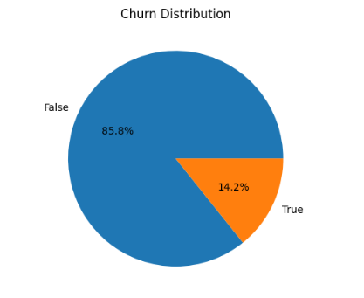

**Pie Chart: Customer Churn Distribution**

* The pie chart shows the percentage of customers who **churned** (left the service) versus those who **stayed**.
* A majority of customers **did not churn**, but there is still a significant portion who left.
* This helps identify the need to focus on reducing churn through better service strategies.

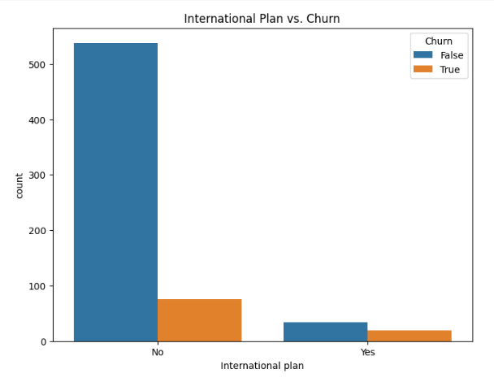

**Bar Chart: Churn Rate Based on International Plan Subscription**

* Customers who have an **International Plan** show a **higher churn rate** than those who don’t.
* This might indicate that the pricing or service for international plans could be a factor in customer dissatisfaction.
* A possible solution is to review international plan charges or provide better benefits for customers using it.

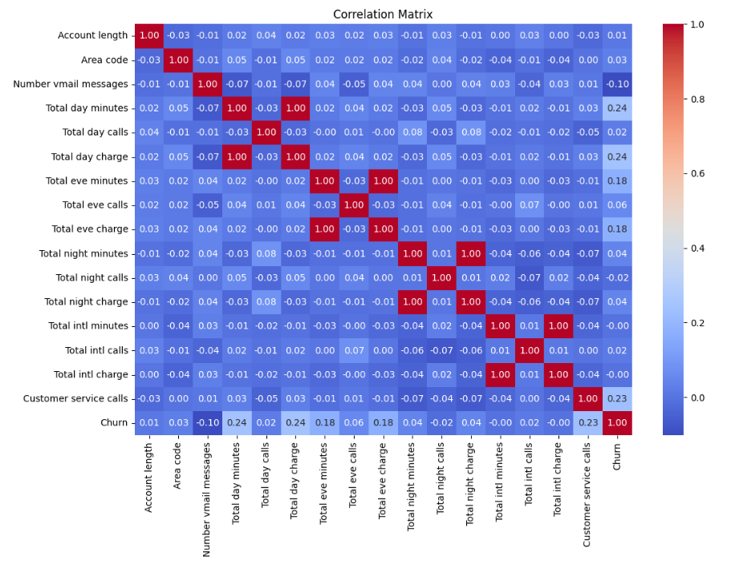

**Correlation Heatmap**

* The heatmap shows how different features are related.
* **Total charges (Day, Evening, Night, International)** are positively correlated with their respective usage minutes.
* **Customer service calls** show a positive correlation with **churn**, meaning customers who call support frequently are more likely to leave.
* **International plan** also has a notable correlation with churn.

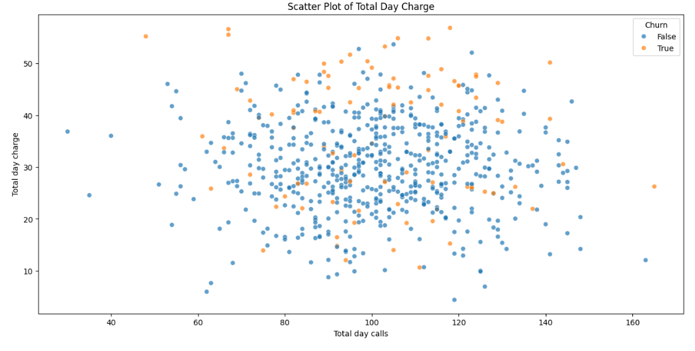

**Scatter plot**:

I used scatter plot for finding the relation between churn rate vs total day charge.

Here I observed if total charge increases churn rate also increases .so many people left from the service this is also one of the reason increasing churn rate.

**Key Insights**

1. **Churn Rate (Pie Chart)**
   * A significant portion of customers **churned**, highlighting the need for better retention strategies.
2. **International Plan and Churn (Bar Chart)**
   * Customers with an **International Plan** had a **higher churn rate**.
   * This suggests that the pricing or quality of the plan may be a concern.
3. **Correlation Analysis (Heatmap)**
   * **Customer service calls** are **positively correlated** with churn.
   * **International Plan** also shows a correlation with churn.
   * Usage-based charges (day, evening, night, international) are correlated with usage minutes.
4. **Customer Service Calls and Churn (Box Plot)**
   * Customers who **made more service calls** were **more likely to churn**.
   * This suggests that poor customer service experience could be driving them away.
5. **Day Minutes Usage and Churn (Histogram)**
   * Customers who use **more daytime minutes** churn more frequently.
   * High-usage customers may be **unhappy with pricing or service quality**.

**Recommendations**

✅ **Improve Customer Support**

* Reduce response time and improve issue resolution efficiency.
* Offer proactive support to high-risk customers.

✅ **Optimize International Plans**

* Review pricing and benefits to make international plans more attractive.

✅ **Retain High-Usage Customers**

* Introduce personalized offers or better plans for heavy users.

✅ **Monitor High Call Volume Customers**

* Flag customers with frequent service calls for priority support.